1. What is the trend of usage of citibike per quarter?

A: It seems to me that people ride citibike when the weather gets a bit warmer. We can see that people ride less bikes during November because of the drop of temperature.

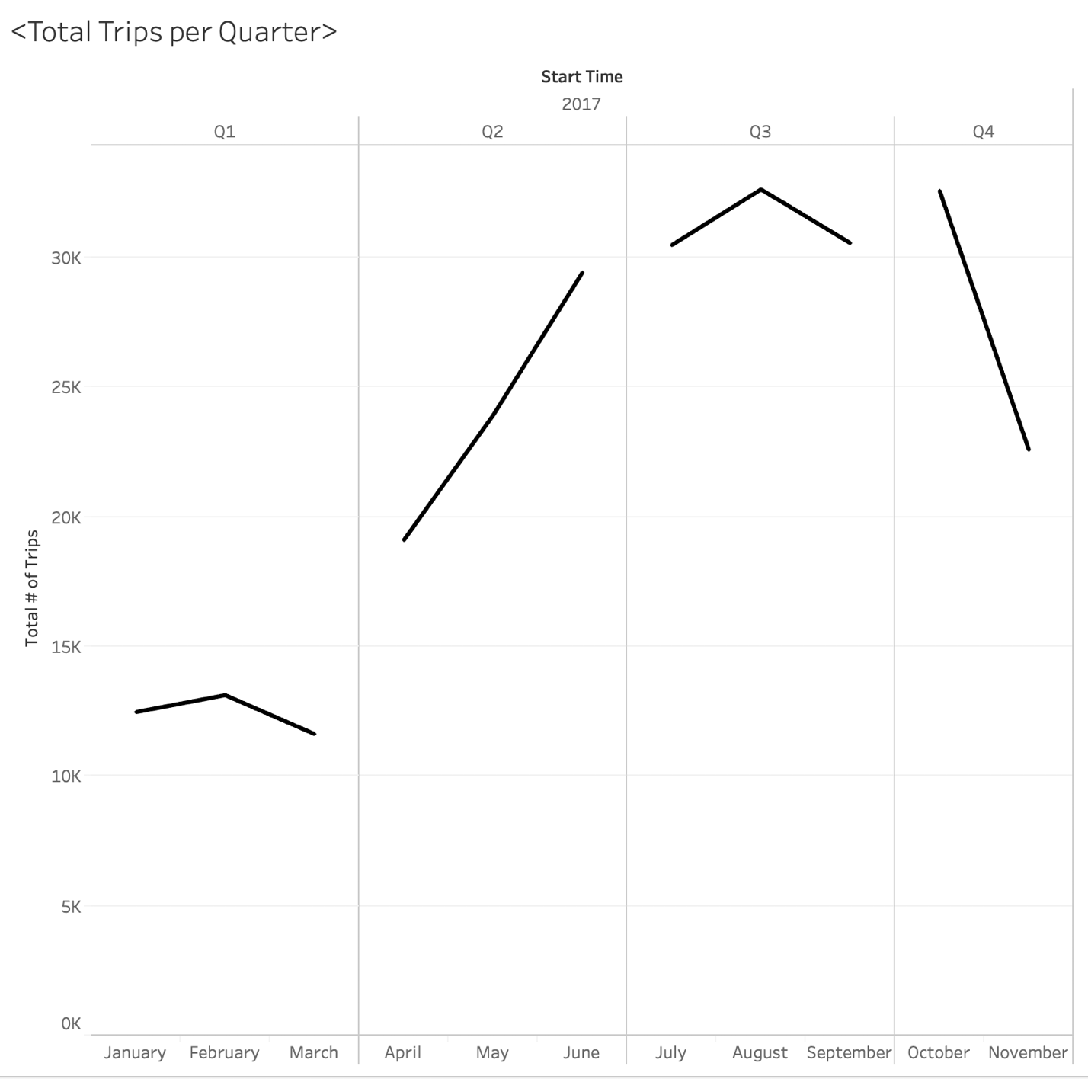

1. What is the trend of usage of citibike for gender in quarters?

A: The trend is pretty much the same, except that there are generally less females that ride citibike than males.

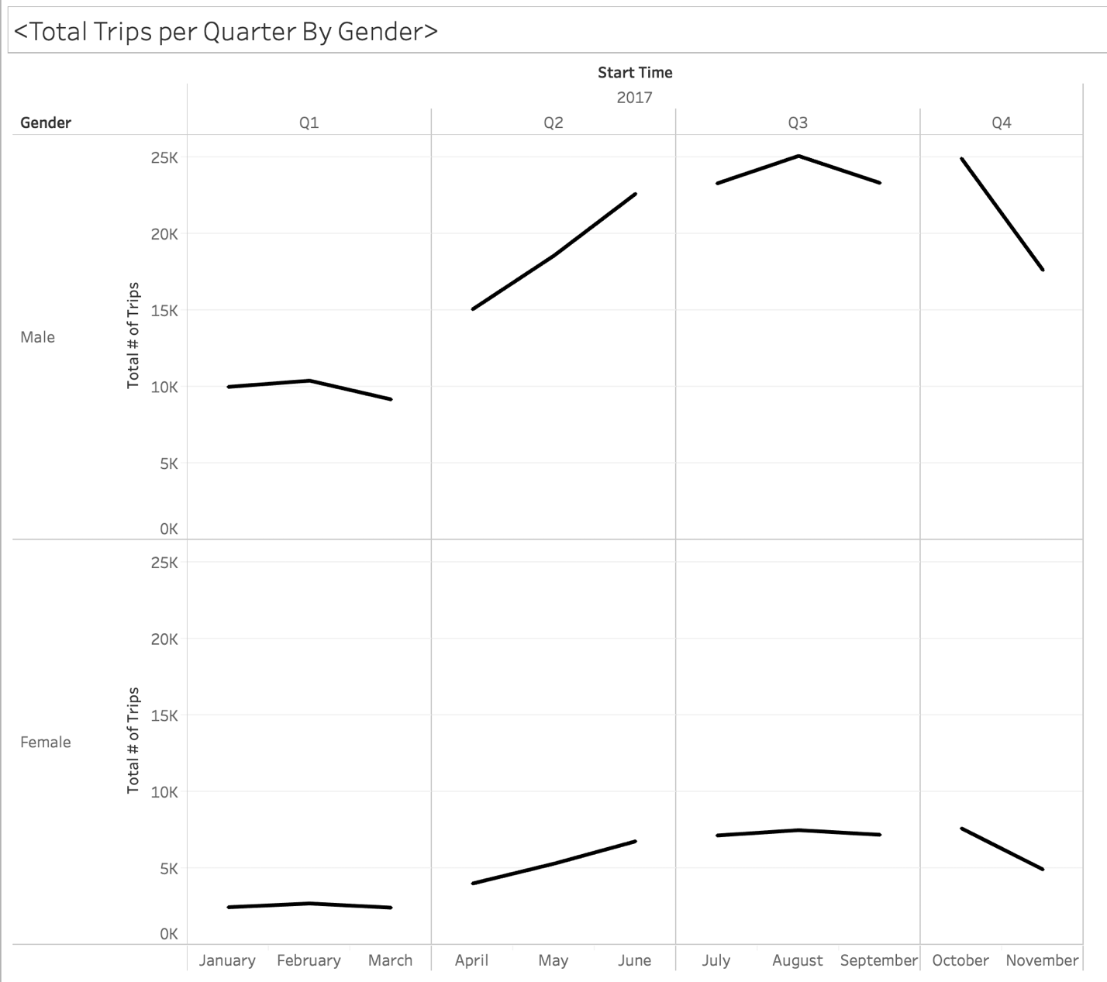

1. Duration of Bike Usage by Quarters & Gender & Minutes

A: If you look at the trend, you can see an upward trend for males from April to July for durations of travel time. If you look at the trend for Females, there is just a slight upward trend from April to August.

